University of Arkansas – CSCE Department
Capstone II – Final Report – Spring 2021

ConDorm Delivery
Jackson LaCrue, Braden Dressendorfer, Reed Vierling, Joshua Francis, Christian Aguilar

Abstract
On average, one in four students will contract a sexually transmitted infection throughout their time in college^{[1]} . Many factors contribute to this disturbing statistic. The topic of sex is stigmatized in our society and this leads to a lack of communication. Also, a subpar sexual education system makes people believe they are more confident in their knowledge on sexual health than they really are.
A mobile app and website focusing on promoting sexual health, when used, would help open the conversation on the topic and make it less taboo. ConDorm Delivery would provide college students with easy and discreet access to sexual health resources. The service allows completely confidential and convenient delivery of condoms, lubricants, and other sexual health resources, including local services and frequently asked questions. By giving students these supplies and information, the user will feel more comfortable and go on to lead a safer and healthier lifestyle.

Problem
A recently conducted survey given to students at the University of Arkansas by Reed Vierling and his McMillon Innovation team yielded some key insights on student life and sexual health. 64% of respondents are sexually active, 30% have had five or more sexual partners, and 41% do not regularly use protection.
Part of the problem is coming from people not feeling fully comfortable talking about sexual health with potential partners. They have the mindset of “what I don’t know won’t hurt me,” but that is not the case. They also assume if they do catch an STI, they will know about it. However, many don’t show symptoms and will likely get passed on to someone else.
The college STI epidemic, if left unchecked, could continue to worsen. Instead of 25% of college students contracting an STI during college, it soon may be 33%. By starting the conversation and educating the students, we would be helping countless students live safer and healthier lives during and after college.

Objective
The objective of this project is to create a web and mobile application students can use to provide them access to the necessary products and information they need to maintain a healthy sexual lifestyle. The website will provide links to reliable sources of information so students can be safer in their private lives, as well as provide an online warehouse-like system where students who would resort to unsafe sex due to financial reasons can still get those materials at no cost to themselves.

Background

Key Concepts
One of the technologies used to implement this project is Heroku. Heroku is a service that enables the user to develop and deploy an app almost instantly to a persistent web server. It supports Java, which we will be using for most of our backend development on the website. It also focuses on security and operations in order for it to be easier for the developer to launch applications. Heroku will allow us to launch our website with little to no difficulty as we develop and test our project.
The second of our key technologies is Swift. Swift is a programming language for iOS. We initially will only deploy an iOS app. Swift was made to be fast; this means our app will allow fast user interface. It is a successor to both the C and Objective-C languages. Swift is also open source allowing the community to further develop and enhance the language.
Using both Heroku and Swift, we plan on deploying a web application as well as an iOS application. We hope to deliver fast applications that are simple to use and will protect the user’s data.

Related Work
Other college campuses have implemented similar programs. One such campus is Notre Dame. Through the “We Got You Covered” initiative, students can be delivered condoms.[2] The difference between their initiative and ours, is that our project will be hosted on a website as well as a phone application. Currently the “We Got You Covered” initiative uses a Google form for orders on a website.[2] This form requests a Snapchat username, which leads to privacy concerns.[2] Our goal is to improve the web design as well as keep the students’ privacy better than the Notre Dame initiative.
University of Denver also has a similar service. There will be two major differences between our implementation and theirs. Firstly, they will deliver to off campus residences.[3] Currently we only plan to implement the project for on campus use. Secondly, they ask the students for a lot of personal information when requesting for a delivery.[3] The information is seemingly used for gathering data on the student body; however, what the data is being used for is never mentioned. Our idea calls for a lot of privacy for the student. We would not require as much personal information from the students (e.g. race, religion, sex, etc.) as the University of Denver does with their program.
Another contraceptive delivery service appeared on Georgetown University’s campus. Georgetown is the country’s oldest Catholic and Jesuit school and for many years did not allow students to have access to contraception on their campus. A student activist group was in charge of changing this. The group has been delivering contraceptives for students on campus. However students in this organization personally deliver the contraceptives[4]. This differs from our methods. We plan on our deliveries being anonymous, but the Georgetown group delivers in person. Our goal is also to find a sponsor to provide the contraceptives, but the Georgetown group provides the contraceptives themselves. Our model is an upgrade because it allows students to have some privacy and we will not have to pay for the contraceptives out of pocket.

Design

Requirements and/or Use Cases and/or Design Goals
The website will allow the user to order condoms. By logging in to the website, the user will have access to the delivery service. The user account will have an associated dorm number and residence hall. The delivery system will temporarily store this information to complete the delivery. The website will also contain useful information on sexual health. This will provide users with links to official government health institutions about sexual health. The app will mirror the functionality of the website, providing a more accessible method for the target audience.

Detailed Architecture
Over the course of this school year our team has learned many things. First, we learned more about working with other people to create fleshed out code. Of course, we have had to work in groups before to complete code, but we have never had to work so long on a project with other people. The main lesson we learned from working together for so long was understanding everyone’s strengths and weaknesses. Everyone on the team is an experienced programmer, but that does not mean that everyone was equally skilled in all areas of the project. Braden and Joshua showed the most experience with the backend. Jackson and Christian showed the most experience with the front end of the website. Reed showed the most experience developing the mobile application. Once we understood how to play to each team members’ strengths the project seemed to progress much faster. Learning how to identify each other's strengths made it easy when it came to writing proposals, presenting, and writing all the code for the project. Speaking of which, everyone in the group was able to expand their knowledge of coding. Braden and Joshua gained a lot of experience working in Python Flask. Jackson and Christian learned a lot about front end development and tricks to making websites look better. Reed expanded his knowledge on mobile development. These lessons made the project well rounded and assisted in making the final product something the whole group can be proud of. It also represents not just a culmination of our work this semester but also the progress each of us has made in our personal development. We also learned how to establish deadlines and goals for ourselves. Having team meetings was of vital importance as it allowed us to establish where everyone was and allowed us to see how to move forward. With our teams separated by focus, this was the best way to bring everyone together and reset before continuing on.
Having completed the project, we can see the potential impact it will have on the world. In fact, the project has nothing but potential. Our goal when we selected ConDorm Delivery was to create a healthier environment for the students on campus. To do so we planned to create the web and mobile application so that students could have access to sexual health resources, but we also planned to get sponsoring from the University. We did not get sponsored by the University. Instead of seeing this as a negative, our group took this in stride. While we saw not getting sponsored by the University of Arkansas as a negative initially, we soon realized that this could be a positive. Not having a sponsorship allowed this project to potentially expand across the United States. Having done the research, our team knows this project could have a huge impact. Already other campuses have programs like this in place. We now have a working application that could go anywhere in the United States. This makes the potential impact of the project that much greater. This project has the chance to save thousands of students from potentially life altering diseases. Hopefully this project will eventually inspire a wave of students to practice safe sex and learn more about how to live a healthy life.
Our team must now ask what can be done to continue improving the project. We have a fully working web application; however, we do not have a sponsor therefore we cannot provide the services we had hoped to provide. Students can still sign up and browse the website, but as of right now the only thing they can gain is resources and knowledge on sexual health. We will need to continue to search for a sponsor as well as make the website meet any needs that a sponsor might have. We also need to work on developing the mobile app more. We have run into issues connecting the app to the backend. Considering the mobile app was the main way we planned to market the project, it is imperative to complete the mobile app. After that there is not much else for us to do. Our group knows younger people in Computer Science so we have thought about passing down the project to them. We are passionate about the project and want to see it succeed, but with many of us starting our lives after college it will be difficult to maintain and update the website and mobile application. The next step for this project will either be finding a sponsor or finding a successor for the project. We are confident that we will be able to find one of the two in the near future.
As for the project itself, we mainly programmed ConDorm Delivery in Python and HTML/CSS/app. Our stack was new to quite a few of our developers, which caused several unforeseen issues that we were slowly able to work our way through. The project can be thought of as having a few key parts – the Python code which runs almost all the logic and data transferal, the HTML, CSS, and app that shaped the website itself, and the local Python Flask and Heroku servers that were used for testing and production, respectively. Diving deeper into those three main groups, starting with what makes it run, we have the Python code.
Most of our Python logic is done in a single file, app.py. This is what we run in our local VMs and on the development server to turn everything on. One of the first things you encounter in this code is the switch between the development and production server, done by changing a single variable. This allows us to easily switch between managing the Heroku server or just managing one we’re hosting locally. The address in the development URL includes the local password to get into the postgres database. Following the database URLs we find several tables for these databases being defined. This is where the meat of our SQL work comes in, and it’s almost all done using Python libraries. One of our future goals, now that we’ve made the working system, would be to look over and consider redesigning some key parts of the database to ensure maximum user privacy. Below this database code we have our Flask code, setting up each of the subdomains for the ConDorm website. Here we designate what happens on each of the pages should they return some value, such as a submission on the Orders page. These changes are then reflected into the database.
Moving on into the HTML and CSS, our website is designed to be simple but easily readable. Our frontend engineers developed a beautiful website design that could overlap the original red-and-tan texture we originally had while still developing the main systems. They also developed the sidebar (now more of a top-bar) that shows links to the rest of our accessible addresses. These will be updated based on your login status and admin privilege. The meat of our HTML consisted of either information (in the case of our About page) or some kind of form (such as our Order page). The information was relatively simple to relay, especially since we are not currently embedding it, choosing a hyperlink for simplicity. For the forms, we had to work with/around a system called Jinja which allowed us limited logic within our HTML. This allowed designs such as a dropdown menu which lists each item in our database as a separate HTML item. Since this was a new system to most of us, we had to fight a bit to get this working as desired. They spent a majority of their time on CSS. Some on learning the basics and most on deciding what to write and troubleshooting. The CSS does most of the work in terms of bringing the front-end together. It not only changes the basic look of the website; it is also being used to ensure the elements are positioned correctly. Managing the layout of the website initially gave them a lot of trouble, as the resulting DOM would present unwanted scrollbars and backgrounds that did not fit the view window after resizing. There are a few options for managing html layout, such as bootstrap, but they chose to use the lightweight CSS-Grids. CSS-Grids allow the designer to arrange elements by attaching an id to each them. Then, the designer will specify their layout intentions in plain text.
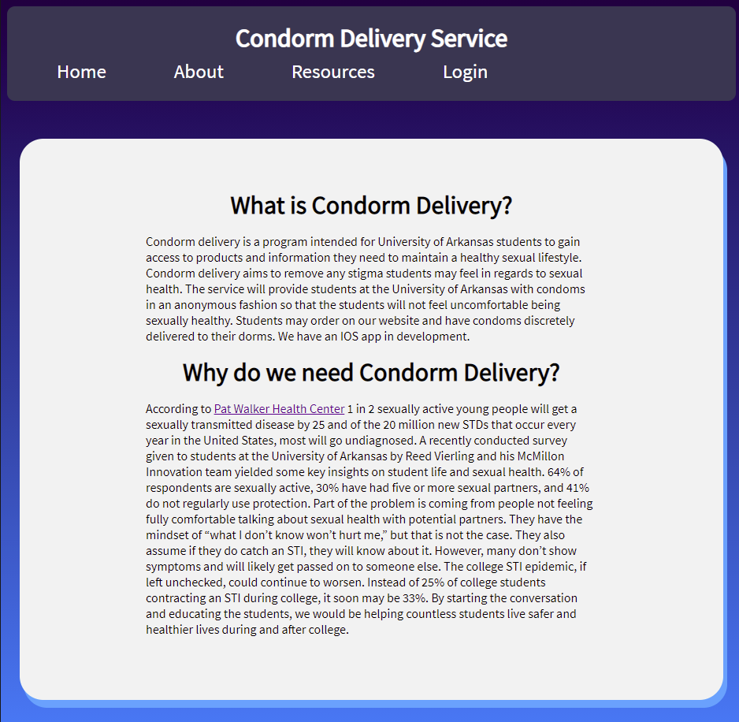
When deciding which mobile version of the Condorm Delivery app we wanted to start with, we decided to go with an iOS application. From our experience as college students, there were much more people we interacted with that used iPhones and other Apple products, so we figured this was the best place to start with a mobile application and we could expand to an android version later. The iOS application of Condorm Delivery was worked on by multiple members of our team. Reed Vierling worked on the frontend of the app, while Braden Dressendorfer and Joshua Francis worked on the backend.
We tried to use a minimalistic approach, as to not distract the user from the main goal of the user either learning about how to live a safer sexual lifestyle or actually practicing a safer sexual lifestyle. Whichever the user wants to do, they are a few clicks away from their goal. You initially start at a login screen where previous users can login or new users can choose to create an account if they’d like. Once they login, the user is taken to a home screen where they have three options to go to new pages. They can choose to place an order, check out our sexual health resources, or learn about what Condorm Delivery does in our About Us page.

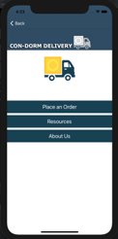
As for how the app was created, Reed used his previous knowledge of swift to code the iOS app. He started with a simple storyboard in Xcode and then went deeper into the actual coding of the application. There were many connections between pages that needed to be made. Whether it was carrying over information from a user’s order or taking a user to one of our resource pages. The app must keep track of what the user has previously input for their order and update that information to our server.
The Flask and Heroku servers were the last step in any part of the process. During development we’d have hours of returning to our PGAdmin site to check on whether the website was working properly, all for a cry of excitement when something finally worked as intended. For production we’d make our last few changes, updating the development status at the top of the app.py file and wiping the database so it could set up any structural changes, and then we’d finally see our code on the live server. While this server was useful for us to prove the project works and is live for consumers, there was drastically more time spent working on the development code. A future hope would be that this is no longer the case, with students using this system actively and requiring more careful management – more work but satisfying work with the knowledge that the system is being used.

Risks
Risk | Risk Reduction
What if a condom breaks in delivery? | Make a liability clause when the user signs up for the service
Guaranteeing delivery on time | Possibly create delivery windows where a delivery person will be guaranteed to deliver the product
Keeping user’s information secure | Delivery person will have no contact with the student

Tasks
1. Research potential sponsors for the project. We plan to get Pat Walker involved.
2. Design an appropriate data model.
3. Design the database around the data model.
4. Design the website.
5. Implement the database.
6. Create an API for accessing the database.
7. Implement the web server.
8. Implement the website, using the API to access the database.
9. Test website UX.
10. Test website API calls.
11. Create the iOS app to mirror the website.
12. Test iOS app UX.
13. Test iOS app API calls.
14. Attempt to implement a trial run on campus.

Schedule
Tasks | Dates
1. Research potential sponsors for the project | 11/16-12/4
2. Start a general layout of the Design Document | 12/4-12/10
3. Build the class website (personal information/about us) | 12/7-12/10
4. Design the database around the data model | 1/11-1/15
5. Design the Condorm Delivery website | 1/11-1/15
6. Implement the web server (And create database API) | 1/18-2/12
7. Test Website UX | 2/15-2/19
8. Create IOS app | 2/15-3/12
9. API for database on app | 3/15-3/20
10, Test IOS UX | 3/22-3/27
11. Final testing of all systems | 3/29-4/23
12. Write up final report | 4/26-4/30

Deliverables
●Design Document: The Design Document will be a document showing what our web and mobile application will look like to the consumer.
● Database scheme and initial data: The DB scheme will include the list of product and amount on hand as well as storing user’s data such as username and password.
● Website: The website will be implemented using the Heroku software with which most team members will be familiar. It uses Java and MySQL for the main functionality. The code for the website will be a handwritten Java system. The main focus of the website, as with the mobile app, will be to provide two objectives: first a means to obtaining sexual health resources that may otherwise be difficult to obtain for students, and second a resource to sexual health information for students, kept up to date by using live updates to outside professional resources. ● Mobile App: The mobile app is the main way we anticipate our project being utilized by the target users. This should mirror the website mentioned above, showing both resources that students can reference for their own health and also devices they can use to help stay healthy with their relationships.
● Final Report & Research Paper: A culmination of the information gathered from the testing and usage of this project. This should be the basis upon which further implementation of the project will be built, possibly being redone by scratch to fit with the new data.
[The final deliverable to the instructor is a zip file containing all reports and code. Also, all results from the project are posted on your website (except, optionally, any proprietary code).]

Key Personnel
Reed Vierling – Vierling is a senior Computer Science major in the Computer Science and Computer Engineering Department at the University of Arkansas. He has completed relevant courses including Programming Paradigms, Operating Systems, Software Engineering, and Database Management Systems. He has experience working on two projects with the McMillon Innovation Studio as an app/web developer and had an internship in the summer of 2020, but unfortunately lost it due to the COVID-19 pandemic. Primarily, he will work on the app version of ConDorm Delivery and will provide assistance with other tasks if needed.
Jackson LaCrue – LaCrue is a senior Computer Science major in the Computer Science and Computer Engineering Department at the University of Arkansas. He has completed relevant courses including Programming Paradigms, Software Engineering, and Database Management Systems. He will primarily work on the web application of ConDorm Delivery and will provide assistance with other tasks if necessary.
Braden Dressendorfer – Dressendorfer is a senior Computer science major in the Computer Science and Computer Engineering Department at the University of Arkansas. He has completed relevant courses including Programming Paradigms and Software Engineering. He has experience in working on multiple web applications that require database manipulation. He will be responsible for working on the web application of ConDorm Delivery and assist with any tasks needed.
Joshua Francis – Francis is a senior Computer Science major in the Computer Science and Computer Engineering Department at the University of Arkansas. He has completed courses such as Database Design, Programming Paradigms, and Software Engineering. He has worked on a project similar in scope to the backend system using the same tools the group intends on using. Francis will be responsible for working on the backend database design and will assist with any other tasks as needed.
Christian Aguilar – Aguilar is a senior Computer Engineering major in the Computer Science and Computer Engineering Department at the University of Arkansas. He has completed relevant courses including Programming Paradigms, Software Engineering, and Database Management Systems. He will be working on the app version and providing assistance to any other tasks as needed.
Champion/Advisor name, Industry champion/professor
We currently do not have an advisor on this project, but will be reaching out to local healthcare companies to seek advice and potentially see if they want to work with us. Reckitt Benckiser, the maker of Durex condoms, has shown interest in a similar project in the past.

Facilities and Equipment
The project will use open-source software and free versions of hosting systems during the trial period. Subscriptions for used trial software and other tools necessary to provide heavy-duty access will be acquired in the event of this trial period proving successful and continuing to production.

References
[1] “Sexually Transmitted Infections,”
https://my.wlu.edu/student-life/health-and-safety/student-health-and-counseling/health-library/stis
[2] “We Got You Covered,” http://irish4reprohealth.org/we-got-you-covered/
[3] “Pleasure Pack Delivery,”
https://www.du.edu/health-and-counseling-center/healthpromotion/sexual-health/pleasurepack-delivery.html
[4] Parenthood, Planned. “Why We Brought Emergency Contraception to My College's Campus.” Planned Parenthood of Metropolitan Washington, DC, Inc., www.plannedparenthood.org/planned-parenthood-metropolitan-washington-dc/blog/why-we-brought-emergency-contraception-to-my-colleges-campus.

