University of Arkansas – CSCE Department
Capstone I – Final Proposal – Spring 2020

ARKSAT-1 Cube Satellite
Karshin Luong, Kyle Davison

Abstract
ARKSAT-1 is meant to set out the very first satellite launch attempt by the University of Arkansas. The main problem trying to be solved is if it is possible to shine a light from our satellite and be able to point and track it from Fayetteville. All the work will be from scratch and the design, safety, compliance, and workflow will be obstacles to our mission. Through working with Nanoracks and NASA, we hope to gain valuable knowledge of the Cube Satellite (CubeSat) development process in order for both ours and future mission success.

1.0 Problem
The question we are trying to answer is the feasibility of detecting a LED on a satellite and to also test fly the University of Arkansas’s first CubeSat in order to gain experience for future missions. This mission will be the forerunner for future missions and provide a basis of how launch mission development is like. The learning process is critical to mission success as we must document and record all our experiences.

2.0 Objective
Create a functional cube satellite that will shine a high powered LED onto the city of Fayetteville when orbiting Earth. Be able to detect the LED from the university and track it as it orbits the Earth.

3.0 Background

3.1 Key Concepts
The key concepts of this project are all related to the development of systems and technology of cube satellites. The main concerns we are dealing with are the electronic wiring and programming.

3.2 Related Work
Many other CubeSat missions have been attempted before ours and thus there is plenty of documentation of former development. The company Nanoracks supplied us with a Lessons Learned[1] document describing the main concerns and design problems that many in the past have run into. This extensive document lists all concerns from materials to unique subcomponents that we may need.

4.0 Design

4.1 Requirements and/or Use Cases and/or Design Goals
- Electronics must communicate through I2C protocol or SPI.
- Sensors and cameras must pass information to the main controller.
- Main controller will transmit data received through a radio band in order for us to recieve on Earth.
- Interface with magnetorquers using PIC microprocessors to orient the satellite.

4.2 Detailed Architecture
The current satellite design will have the LED “tuna can” (a LED encased in an aluminum cylinder) on the bottom of the cube with 3 higher resolution optical cameras around it. Each of the other faces will have a low resolution IR camera for tracking where Earth is. Inside the satellite will be the main control board with an Arduino MKRZero and several PIC controllers for the sensors. There will also be 2 power systems, an uncharged battery cell array and a ClydeSpace EPS at half charge. Finally, we will have a radio wave transmitter and receiver that will be used to send and receive data/instructions. Other systems include solar panels throughout the shell of the satellite and magnetorquers on each face of the cube in order to rotate.
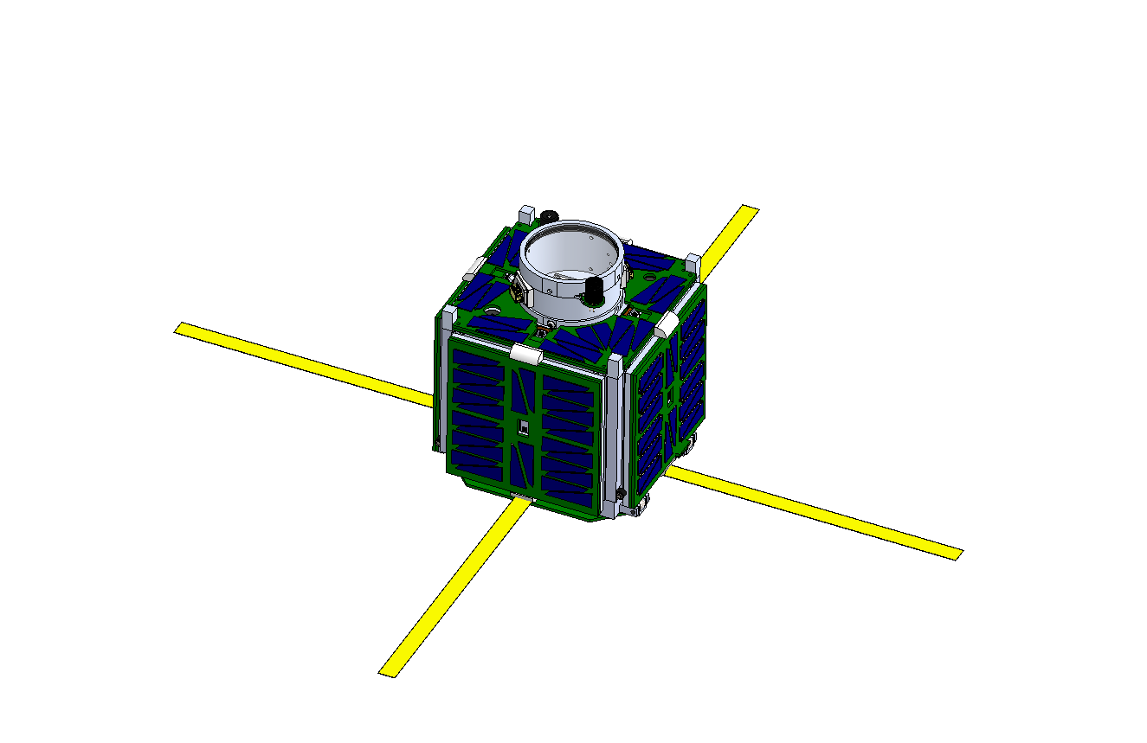

For software, the structure of the code is still being debated. There will be multiple files that will be loaded onto the PIC microcontrollers onboard and help communicate with the Arduinos. The arduinos will handle most of the algorithms to pinpoint location and organize data. Sending and receiving data will also be done by the Arudinos and will be broadcasted back to Earth. Many of the design aspects for software are unknown due to not having a prototype to test different configurations. There are not many resources online of other missions and so software will be the main aspect of the mission that will need to be tested extensively.

4.3 Risks
Risk | Risk Reduction
LED turning on unexpectedly | Working in conjunction with physical inhibits, we will make sure LED power supply will remain at a low voltage until LED is needed.
LED draining power | Rigorous testing to make sure LED only turns on at the proper time
Not completing the project | Regular visits to the lab, weekly meetings with our team and biweekly meetings with Nanoracks, and a design schedule will ensure that the project will be finished.

4.4 Tasks –
- Learn about the electronic components in the design. PIC microcontrollers use PICBASIC and Arduinos use a version of C.
- Learn about the I2C protocol used to communicate between controllers and pass data.
- Learn about SPI protocol for communication between higher resolution camera and hardware.
- Develop code for communication between sensors and PIC controllers.
- Develop code for communication between arduino and PIC controllers.
- Develop code for orientation of satellite.
- Develop code for centering the satellite camera towards the Earth.
- Develop code for pinpointing Fayetteville.

4.5 Schedule
Tasks | Dates
1. Become familiar with relevant technologies | 10/1-11/1
2. Learn about I2C Protocol | 11/1-11/7
3. Develop code for PIC and Arduino communication | 11/8-11/15
4. Develop code for PIC and sensors communication using I2C | 11/16-11/30
5. Learn about SPI protocol | 12/1-12/15
6. Develop code for Arduino and Camera communication using SPI | 12/16-12/31
7. Learn about data storage on Arduino | 1/13-1/15
8. Develop/test data transmit and receive code | 1/16-1/21
9. Develop/test software serial communication between Arduinos | 1/22-1/30
10. Develop/test code for communication with sensors | 1/31-2/15
11. Develop code for orientation of satellite | 2/15-2/29
12. Add the ability for satellite to find Earth | 3/1-3/15
13. Add the ability for satellite to pinpoint Fayetteville | 3/16-3/31
14. Perform safety and reliability tests/ optimize design | 4/1-4/30

4.6 Deliverables
- PICBASIC code for PIC controllers that will communicate with an Arduino, sensors, and cameras.
- Arduino code for receiving and sending data between components.
- Arduino code for translating data into radio in order to receive data from Earth.
- Reports on development of code and circuit design.

4.7 Work Done
Karshin Luong - Luong was tasked with working with the PIC microcontrollers used for interfacing between the sensors and cameras of the satellite. He focused on learning the programming language called PICBASIC and working with the breadboard for the 2019 Fall semester. Simple programs were written to test small components and how the code would translate to the breadboard. He then moved on to learn a bit about the Arduino components and features such as implementing an OLED screen for display and getting data from a temperature sensor. In the Spring 2020 semester, Luong worked on communication between the various electronic components on the satellite. First he began with PIC to PIC communication, then Arduino to PIC, and finally PIC to Arduino. During the off hours, Luong and Davison would share what they had learned in order to be able to assist each other when needed. Collaboration with Davison helped make the process smoother as PIC to Arduino was where they encountered a roadblock. This was due to the fact that while Arduino to PIC was simple to understand once it was working, PIC to Arduino had little to no documentation or online resources. It was after this point that sadly the university had to close due to COVID-19 and we could no longer work in the lab.

Kyle Davison - For the Fall 2019 semester, Davison mainly focused on becoming familiar with the particular Arduino the satellite would use, the MKR Zero. By the end of Fall, Davison began prototyping sensor communication code, but wouldn't have much success in this until Spring 2020. In the Spring semester, Davison’s initial focus was on interfacing the various sensors with the Arduino microprocessor. Before the university closure, he was able to get all sensors to communicate with the Arduino. This involved soldering the individual sensors themselves and then developing test programs. He also had example programs of communication between two Arduinos. Another task he completed was developing code to store pictures from one of the cameras onto an SD card located on the Arduino. He collaborated with Luong to work on getting the Arduino and PIC to communicate with each other. Due to the closure of University buildings, they were not able to fully finish this task.

4.8 Future Work/Goals
While our development cycle had to be cut short due to coronavirus, the documentation of our research and design process should help the next group proceed more smoothly. Software design was about to be the group’s main focus because the machining group and electronic board design was about to be finalized. This would mean that Dr.Huang and several other group members would have been able to assist in the programming aspect of the mission. The last form of communication we had left off on was Arduino to PIC and once that was working we would begin to assemble the electronic components. We would then need to begin programming the entire satellite's electronics and allow them to communicate as a unit. This bottom-up approach was taken as the learning process and development seemed the most reasonable for our purposes.

With most of the basic device interfacing done, the rest of the programming would be higher level functionality. A specific example would be to have the Arduinos sync up thier sensor data and use that data to determine how the satellite should orient itself. Another task would have been to help program the ground station radio to interpret satellite data and send commands. Finally, if testing for the electronics went well and we managed to finish all the satellite deliverables, we would have been able to assist in pre launch date testing from NASA. Battery testing, shock testing, temperature testing, and most likely many other tests still needed to be done and submitted to NASA.

5.0 Key Personnel
Karshin Luong - Luong is a senior Computer Science major in the Computer Science and Computer Engineering Department at the University of Arkansas. He has completed Digital Design, Computer Organization, and has worked with electronics in the past. His responsibilities will be to get the electronic components of the cube satellite to properly communicate and send data.
Kyle Davison - Davison is a senior Computer Science major in the Computer Science and Computer Engineering Department at the University of Arkansas. He has completed Digital Design, Computer Organization, and is learning more about microprocessor programming through individual study. His responsibility is to prototype design features that may be used in the satellite. He will also implement the final design choices.
Champion/Advisor name, Industry champion/professor – Dr.Huang is the professor leading this project and he has had extensive background in both aerospace and mechanical engineering. He teaches a majority of the aerospace classes the University of Arkansas provides and is running two other design teams as well as ARKSAT-2 which will launch a year after ARKSAT-1.
  - Facilities and Equipment
Edward Durell Stone House (Lab location)
Lab computers
Breadboards
Oscilloscope
Electronic components(Arduino, PIC controllers)
Multimeters
IR Sensors
Cameras

7.0 References
[1] Henry B. Martin, Conor G. L. Brown, Tristan A. Prejean, Nathan D. Daniels, “Bolstering Mission Success: Lessons Learned for Small Satellite Developers Adhering to Manned Spaceflight Requirements”, Nanoracks LLC, 2018

