Team #4 - ServeSmart
19 March 2020

Project Update #2

Our project is ServeSmart, the newest total restaurant POS management system! We incorporate great UI/UX that workers want to use with deep analytics business owners need. Our tech stack consists of a React Native front-end running on a specific Android tablet, with a firebase centered back-end to handle all user authentication, database management, and other data related services. We are embracing some new technologies on this project like NoSQL databases to help put us ahead of the competition.

Progress on our project has been steady through the semester yet slowed as of late. Listed below are some of the achievements we have made since the last update:

- Authentication has passed through testing, which makes the home screen nearly finalized (there will be a global styling overhaul when development of the app’s functionality is finished, the UX here is NOT final).
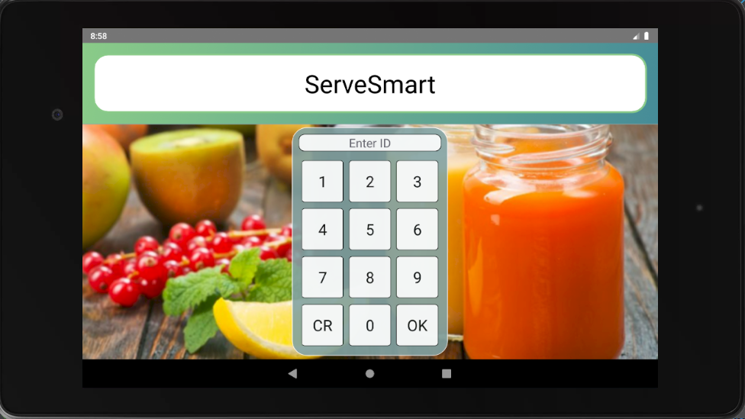
- The layout and design of the landing page has been improved. A side navigation drawer opens up revealing the application features to the user, which are currently under development and not all present. Obviously, we did not feel inclined to map out a complete restaurant floor, so there only exists 3 tables to manipulate and modify (for now, of course).

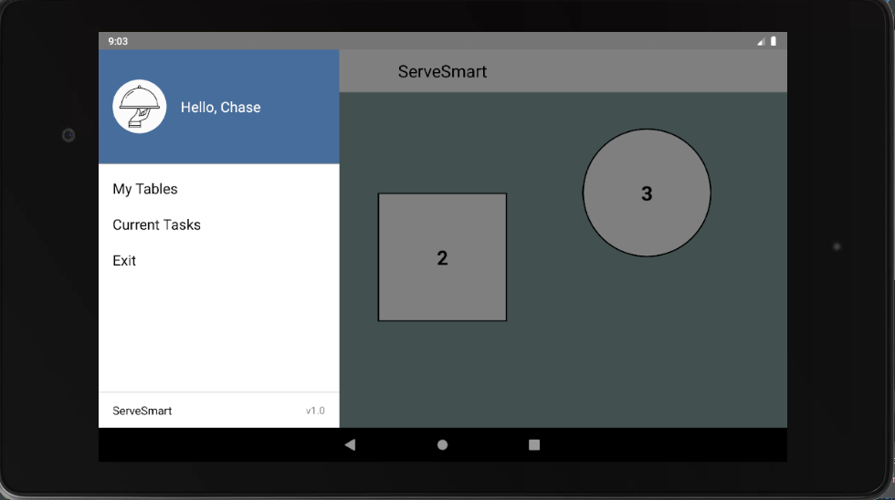
Eventually, the restaurant floor will act as a “map”. Not only will the user be able to scroll around, zoom in and out, and select tables, but their respective section will be highlighted and display information via banners and badges.

- Admin privileges have been added for specific users (i.e. management) which allow them to manage other users, settings, menu data, and miscellaneous information via an in-app UI.

Other screens and features that are still in early development stages are not shown. Stay tuned!

