University of Arkansas – CSCE Department
Capstone II – Preliminary Report – Fall 2021

The Apron App
Team #6
Kayla Boyd, Bertrand Kalisa, Soroush Shirali, Luis Pinzon, Gregory Renteria, Rachel Culbertson

Abstract
The complexity of meal planning ranges from ordering fast food and buying ready-to-eat meals to planning out complex meals. In most cases, people plan out what meals they're going to make along with what groceries they need, usually on a weekly basis. This task can end up requiring a significant amount of time and consideration, especially when factoring in diets and fixed budgets. Poor planning also results in wasted food and money and unhealthy diets. Our approach towards simplifying this process is to create an easy-to-use web application that could handle much of the work involved with planning meals. The app could create a grocery list based on meals you have selected in the click of a button and filter out meals based on cost/diet etc. saving users time and effort. It could also allow users to enter in what groceries they already have and recommend recipes accordingly, reducing food waste.

1.0 Problem
Meal planning can be a time-consuming and cumbersome task and is often regarded as the worst part of cooking. Many people choose to avoid spending much time planning meals, instead opting for easier methods for obtaining food such as ordering takeout, getting fast food, and eating quick frozen/microwavable meals. This is especially true for college students and young adults who are new to cooking and/or feel they do not have time in between studying, working, and socializing. Although fine in moderation, these methods can become problematic in terms of receiving adequate nutrition and high costs.
This project also addresses the issue of food waste. It is estimated that in the US, up to 40% of food produced goes to waste. US households alone waste approximately 76 billion pounds of food per year, accounting for 21 percent of all food waste. [1] Although wasting food may seem like a trivial issue to some, that waste can quickly accumulate leading to adverse effects on the environment including greenhouse gas emissions and excess water usage. A lot of food is wasted due to poor planning when buying ingredients for meals. In the average American household, many ingredients end up expired before they are used, and portions of meals are often thrown away because the portion sizes are too large.
Additionally, a significant portion of the population has at least one type of dietary restriction. According to a study on special diets by the NCHS, around 17.1% of adults aged 20 and up were following a special diet at any given day in 2015-2018. [2] This study asked about health or weight loss related diets, excluding diets for ethical or religious reasons. Therefore, an even larger percentage of the population has specific dietary requirements and that number is estimated to grow. People with dietary restrictions need to take extra care when planning what meals to eat and may have additional requirements related to their diet. For example, someone on a vegan diet may also have a fixed budget for their groceries, further restricting their options for food. These details highlight a growing need for resources for planning meals.

2.0 Objective
The objective of this project is to create a web application to assist users in meal planning. This app will support a variety of features including login/sign up authentication, saving favorite meals, profile management, recommending meals based on ingredients the user already has, and a calendar. The project addresses the issues of time management, food waste, and dietary restrictions related to meal planning.

3.0 Background

3.1 Key Concepts
Since our main goal is to develop a web application, in this section we discuss some of the technologies that are used for its construction. They were selected following parameters such as team members' knowledge or suggestions about languages, databases, frameworks, and APIs that are easy to work with.
Therefore, the key components used in this web application are based on software needs such as tools for frontend/backend development, databases, website frameworks, APIs, source control, and collaboration project boards.
In terms of the frontend development, our decision was to use React because this technology will facilitate for us the creation of a web app which can synchronize with databases for data interaction and at the same time being fast, scalable, and simple.
For our database, we thought that MongoDB would be a great option to use thanks to the flexible document schemas it offers. After reading some basic documentation, we will learn how to model and manipulate data using any kind of data structure. Also, MongoDB is code-native, which will allow us to access it from the language of our preference.
Considering database interactions and calculations, we chose NodeJS to be our main technology for backend development. This is a great option because of the experience we already have working with OOP languages. Its simplicity will be beneficial to web development cross-platform having the ability to scale up quickly.
In order to have more tools and resources at our disposal, we will use the Express framework. Since it only requires JavaScript knowledge, we can easily build different kinds of web components in a short amount of time. Moreover, it provides a simple routing for requests made by clients.
After looking up some technologies available for recipe/calendar APIs, we found interesting options. For example, for food/recipes we have APIs such as Spoonacular, Nutritionix or Edamam some of them being free to use. At the moment we do not have a specific recipe API that we will use. However, we know that the main use of the API will be to establish matching relationships between the ingredients we have available with the recipe options the tool recommends. For calendar APIs, we chose Google Calendar which is free to use and allows us to edit meal planning events, set reminders, or simply complete tasks.
Because of our previous experience in classes such as Software Engineering, we agreed on using Github as our source control platform. This tool simplifies the process of working with other people and makes it easy to collaborate on projects. Our team members can work on files and easily merge their changes in with the master branch of the project.
Finally, for our project collaboration tool, we will use Trello. It is a visual work management tool that will help us ideate, plan, manage, and accomplish tasks together in a collaborative, productive, and organized way. Our plan is to create a board where we will have a series of lists, with a bunch of cards attached categorized by completion levels (To do, Doing, Done). Moreover, these cards will be labeled with a team member whose task will be assigned.

3.2 Related Work
During some of our team meetings, we discussed how authentic our idea needed to be, since we did not have a clear goal for our website. Therefore, we came up with the idea of implementing a web app for giving people ideas about what to cook with what they already have in their houses. However, since there were several websites with a somewhat similar goal, it was a clear indication that we had to change our approach slightly.
We found that some developers have created websites in a blog style to feature delicious, healthy, family-friendly recipes. For instance, the blog website Skinnytaste of the recipe developer Gina Homolka began in 2008 with the idea of presenting recipes anyone is able to cook to improve people’s self-esteem or just to spend valuable time with other members of the family in the kitchen. [3] At Skinnytaste.com, we can find different types of dishes for people hungry and eager to learn how to cook on a daily basis.
Even though this website is similar to the website theme we have, it is just a blog with several sections classified by special diets, travel meals, and cookbooks, where Homolka can publish her own experience after cooking. Definitely, we could improve this idea with our website since it will contain several other features than just recipes with brief descriptions.
Another example found was the website Recipeat, which contains multiple functionalities similar to the ones we were planning such as having a sign up/sign in page, profile page, and recipe generator based on ingredients available. [4] The way how Recipeat works is by first creating a profile to become part of the community. Then, after users check what ingredients are available in the kitchen, they list them on the website for it to generate a recipe. Another feature that this website supports is that it can synchronize with social media such as Facebook, Twitter, or Instagram.
We thought that we could use this website as a reference for our idea since we like how the developers created it. However, we would like to implement some other extra features like a calendar to organize virtual food events with other members of the community or even the possibility to make the web application cross-platform (if time allows).

4.0 Design

4.1 Requirements and/or Use Cases and/or Design Goals
In this project we will be required to make a list of all or various recipes for breakfast, lunch, and dinner. We shall break it into different parts for example recipes for vegetarian food, recipes that are sugar free, or gluten free recipes etc. So, we’ll basically break all those different recipes into different categories and for this, we shall use a hamburger icon that will consist of all those different categories. So, to do that we will use a database that will store all the different ingredients data. We will also use a calendar api to use the calendar feature which will basically be showing the user the saved recipes for breakfast, lunch, and dinner for the whole week/month. We will also have a pantry feature as part of our design goal, that will help users save whatever ingredients they have with them at home and basically add ingredients or remove them if they run out, and from this the app will help them. Additionally, we shall have a save feature where users will be able to save their favorite recipes and easily view/ access them from the save feature.

4.2 High Level Architecture

The MERN stack is a full-stack development protocol, which is an industry standard created by the teams at facebook, for dynamic web applications acronym: Mongo, Express, React and Node. These allow client side rendering while all being based in javascript. Mongo is the database in JSON form, express it supports the backend framework built on top of node.js, react is the front end framework for UI/UX, and Node is the javascript run-time environment.
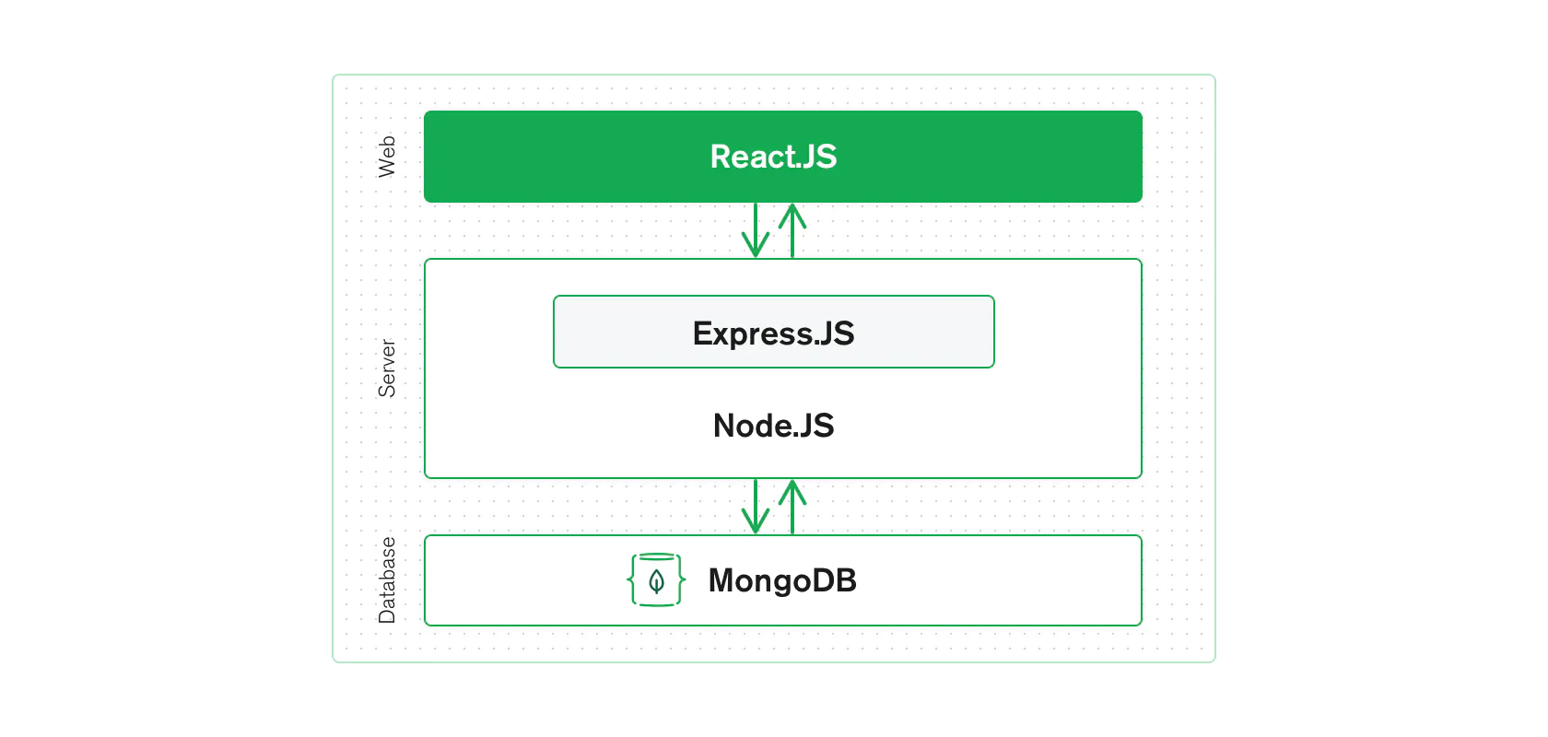
Our project will utilize the Model-View-Controller (MVC) architecture pattern. MVC divides an application into three components: Model, View, and Controller that each handles a specific development aspect of an application. [5] The Model handles the app’s data storage/management and its main logic. It works independently of the User Interface. The Controller provides an interface between the Model and View and is used to update the Model based on user interaction. The View defines how the information from the model will be displayed and how the user can interact with the application. MVC results in a separation of logic between different components, allowing for easier development and debugging.
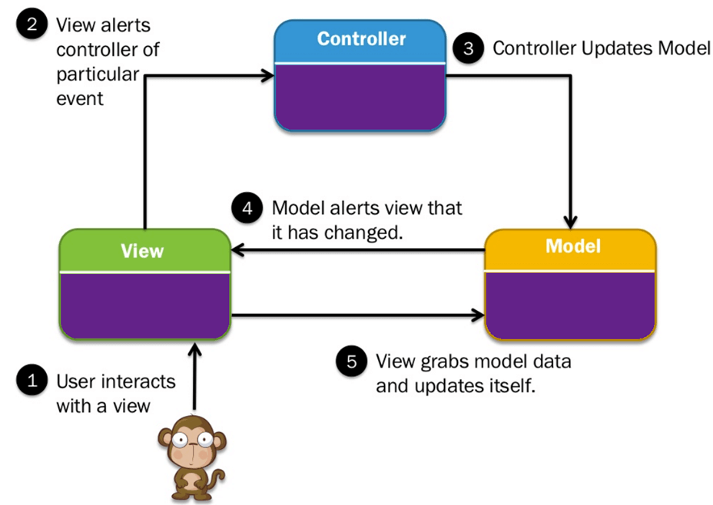

4.3 Risks
Risk | Risk Reduction
Enabling Proper Encryption for database regarding passwords/user information | We will be using a facebook standard for creating a dynamic web page (MERN Stack) and handle all user encryption using SHA-256 Hash/SALT to allow for best industry standard encryption.
Scalability when dealing with an influx of client requests | By using Mongo we will have the built in scalability, along with running on multiple servers to ensure better probability of losing crucial data. information around building the web application is very abundant on the internet, so we will have plenty of sources to reference.
Testing a vast majority of different OS/Device intercompatibility to be best optimized for all users. | We will use a responsive web which will allow us to adjust a website content into the best layout for the device it is being displayed on. Creating a responsive web page is crucial for making a user friendly experience.

4.4 Tasks
1. Work on preliminary proposal and presentation
- Identify the concepts and objective of the projects
- Understand the goals and obstacle of future users
- Write initial proposal
- Delivery proposal presentation
2. Initial app planning
- Work on the wireframe for each of the screens of the app:
-Discuss UI design pattern and color palette
- Create a user-flow diagram and discuss navigation for each screen.
- Discuss improvement in the layout of the app
- Balance simplicity vs usefulness
- Make final decisions on what features the app will have
- Make final decision on technologies which is best suited for the project
- Having a mockup
- Define architecture
- Gather recipes (Research APIs for finding online recipes)
3. Setup for environment
- Create a Github repository for the team.
- Create and design MongoDB schema, beginning with user authentication.
- Become familiar with MERN architecture.
4. Development
- Create login/sign-up functionality
- Create and design MongoDB schema for storing user data.
- Design and create UI and implement login and sign up pages
- Design and implement different activities layout(Homepage, etc)
- Implement API for user authentication
- Retrieve and display recipes on home page
- Set up database
- Add recipe save feature
- Implement other features of the app
5. Deployment of the app
6. Finish fine tuning the website and testing use cases
- Perform functional testing
- Perform performance testing
7. Final report and presentation

4.5 Schedule

Tasks | Dates
1. Work on preliminary proposal and presentation | 8/23-9/13
- Identify the concepts and objective of the project | 8/23-8/27
- Understand the goals and obstacle of future users | 8/30-9/3
- Write initial proposal | 9/7-910
- Delivery proposal presentation | 9/10-9/15
2. Initial app planning | 9/17-9/24
- Work on the wireframe for each of the screens of the app:  -Discuss UI design pattern and color palette  - Create a user-flow diagram and discuss navigation for each screen.  - Discuss improvement in the layout of the app  - Balance simplicity vs usefulness | 9/17-9/20
- Make final decisions on what features the app will have | 9/20-9/22
- Make final decision on technologies which is best suited for the project | 9/20-9/22
- Gather recipes (Research APIs for finding online recipes) | 9/22-9/24
- Define architecture | 9/22-9/24
- Having final mockup | 9/24-9/27
3. Setup for development | 9/27-10/1
- Create a Github repository for the team. | 9/27-9/29
- Become familiar with MERN architecture. | 9/27-10/1
4. Development | 10/1-11/15
- Create login/sign-up functionality | 10/1-10/6
- Create and design MongoDB schema for storing user data. | 10/1-/6
- Design and create UI for login and sign up pages with ReactJS | 10/8-10/15
- Implement API for user authentication | 10/8-10/15
- Retrieve and display recipes on home page | 10/15-10/20
- Add recipe save feature | 10/15-10/20
- Implement other features of the app | 10/20-10/30
5. Deploy app | 10/20-10/30
6.Finish fine tuning the website and testing use cases | 11/2
- Perform functional testing  - Perform performance testing | 11/2-11/15
7. Final report and presentation | 11/15

4.6 Deliverables
- Design Document: Documentation of all software used. This includes React, NodeJS, Express and MongoDB.
- Database schema and initial data: The DB schema is for MongoDB and we will also be using a recipe and calendar API.
- Website: Will allow the user to find recipes based off of the items they have in their pantry along with other features including: a login/signup page, home page/feed, profile, pantry, calendar, saved recipes, and a hamburger menu to navigate.
- Final Report

5.0 Key Personnel
Rachel Culbertson – Culbertson is a senior Computer Science major at the University of Arkansas. She has completed courses in Computer Graphics, Database Management Systems, and Artificial Intelligence. In the summer of 2021, she worked as an IT Intern for Tyson. She currently works as a Research Assistant in the Data Science lab.
Kayla Boyd - Kayla is a senior Computer Science major at the University of Arkansas. She has completed courses in Big Data Analytics and Management and Algorithms. Since the summer of 2021, she has been an Application Development intern in the Engineering and Technology Department at JBHunt. She also has experience in front end web development.
Gregory Renteria - Gregory is a senior double majoring in Computer Science and Computer Engineering at the University of Arkansas. He has completed courses in Computer Graphics, Database Management Systems, and Introduction to Game Design I/II. He is currently interning as a software developer at Junction AI, where he is in charge of the data ingestion pipeline using AWS environments.
Luis Pinzon- Luis is a senior double majoring in Computer Science and mathematics at the University of Arkansas. He has completed courses in computer networks, algorithms and Database Management Systems. Since the Summer of 2021, he is part of the Network Enterprise Team at the University of Arkansas as network technician.
Bertrand Kalisa- Bertrand is a senior majoring in Computer Science at the University of Arkansas. He has completed courses in Database Management Systems, Computer Networks, Algorithms and Formal Languages. He is currently working at the TechSpot at the University of Arkansas as a lab technician.
Soroush Shirali - Soroush is a senior major at University of Arkansas. He has worked for Tech Genius as a project manager. He is currently TA for digital design and on the All University Academic Integrity Board as an undergraduate representative.

6.0 Facilities and Equipment
Some of the facilities used for this project will be computer labs such as the Acxiom lab at JBHunt, TechSpot labs, and sometimes the Mullins Library meeting rooms. Moreover, our meetings sometimes will not be held in person, so we can meet virtually using video calling software such as Microsoft Teams.
In terms of the equipment required, we will mostly use our own laptop/desktop computers to develop our project. However, in case we need to check out additional hardware equipment, we will make use of some of the resources the Student Tech Center offers.

7.0 References
[1] Gunders, Dana, and Jonathan Bloom. “Wasted: How America Is Losing Up to 40 Percent of Its Food from Farm to Fork to Landfill.” Https://Www.nrdc.org/Sites/Default/Files/Wasted-2017-Report.pdf, Natural Resources Defense Council 2017, Aug. 2017.
[2] Stierman, Bryan, and Suruchi Mishra. Special Diets Among Adults: United States, 2015–2018. NCHS Data Brief, Nov. 2020, www.cdc.gov/nchs/data/databriefs/db389-H.pdf.
[3]“Delicious Healthy Recipes Made with Real Food.” Skinnytaste, AN ELITE CAFEMEDIA FOOD PUBLISHER, www.skinnytaste.com/.
[4]Recipeat, 2020, recipeat.in/.
[5] Martin, Matthew. “MVC Framework Tutorial for Beginners: What Is, Architecture & Example.” Guru99, 28 Aug. 2021, www.guru99.com/mvc-tutorial.html.

